

Vendor Inspection Integration Requirements

Table of Contents

Schemas 2

Inspection Request 2

Inspection Response 2

Understanding the Inspection Request Structure 2

WORKORDER 2

INSPECTIONFORM 2

INSPQUESTION 2

INSPFIELD 2

DEPENDENCIES 3

INSPECTIONRESULTS 3

Example of how INSPFIELD.REQUIRED and the DEPENDENCIES section work together 4

No DEPENDENCIES Example 1 4

No DEPENDENCIES Example 2 4

DEPENDENCIES Example 1 5

DEPENDENCIES Example 2 6

Inspection Response Guidance 7

Found In Field (FIF) 8

Troubleshooting 10

# Schemas

## Inspection Request



## Inspection Response



# Understanding the Inspection Request Structure

## WORKORDER

* WONUM – Maximo work order number.
* ORGID – Maximo organization requesting the inspection.
* SITEID – Maximo site requesting the inspection.
* VENDOR – Maximo vendor performing the inspection.

## INSPECTIONFORM

* INSPFORMNUM – Inspection form number.
* REVISION – Active revision of the inspection form.
* NAME – Name of the inspection form.
* INSPQUESTIONS – Contains an INSPQUESTION node for each question on the form.
  + INSPQUESTION – Information defining the question.
    - INSPFIELD – Information defining how the question should be answered.
      * DEPENDENCIES – Information defining the dependencies between the current question and another question.
      * INSPFIELDOPTION – Options for multi-option questions.

## INSPQUESTION

* SEQUENCE – Sequence of the question.
* INSPQUESTIONNUM – Unique ID of the question.
* DESCRIPTION – Question text.
* INSPFIELD – Information defining how the question should be answered.

## INSPFIELD

* INSPFIELDNUM – Unique ID for the answer.
* DATATYPE – Defines the type of answer.
  + TXTRESPONSE – Text answer.
  + DATERESPONSE – Date answer.
  + SO-TXTRESPONSE – Multiple options available, but choose only one.
  + MO-TXTRESPONSE – Multiple options available and multiple can be chosen.
* REQUIRED – Defines, in combination with the DEPENDENCIES section, whether a question is required or not. If there is no DEPENDENCIES section, this REQUIRED field is the sole determination of whether a question is required or not.
* VISIBLE – Defines, in combination with the DEPENDENCIES section, whether a question is visible on the form or not. If there is no DEPENDENCIES section, this VISIBLE field is the sole determination of whether a question is visible or not.
* DEPENDENCIES – Contains information about the question the current question is dependent on. Also, potentially overrides the REQUIRED and VISIBLE flags depending on how the previous question was answered.
* INSPFIELDOPTION – Options for SO-TXTRESPONSE and MO-TXTRESPONSE type questions.
  + DESCRIPTION – Option.

## DEPENDENCIES

* SRCQUESTION – INSPQUESTIONNUM the current question is dependent on.
* SRCFIELD – INSPFIELDNUM value the current question is dependent on.
* SRCTXTRESPONSE – Answer the current question is dependent on.
* REQUIRED – Defines whether the current question is required based on the answer to the dependent question.
* VISIBLE – Defines whether the current question is visible based on the answer to the dependent question.

## INSPECTIONRESULTS

* INSPECTIONRESULT – Contains information for each Asset/Location pair.
  + INSPFORMNUM – Inspection form number.
  + REVISION – Active revision of the inspection form.
  + REFERENCEOBJECT – Object in Maximo to store the relationship between the Asset/Location pair and the Workorder.
  + REFERENCEOBJECTID – Unique ID for the REFERENCEOBJECT object.
  + RESULTNUM – Unique ID to tie the answers back to the inspection form.
  + ASSET – Asset number.
  + LOCATION – Location number.
  + ATTRIBUTES – Contains attribute information for the asset and location.
    - ATTRIBUTE – Repeating node for each attribute key/value pair.
      * ATTRID – Attribute name.
      * ATTRVAL – Attribute value.

## Example of how INSPFIELD.REQUIRED and the DEPENDENCIES section work together

### No DEPENDENCIES Example 1

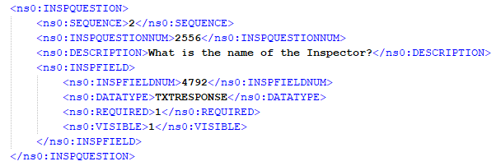

This question is visible and required to be answered.

### No DEPENDENCIES Example 2

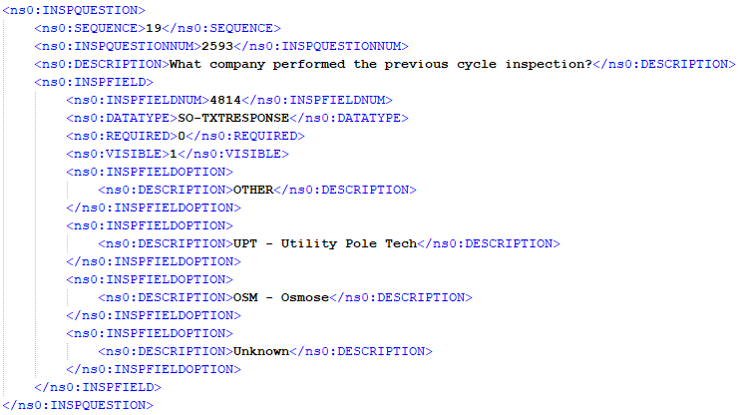

This question is visible, but is not required to be answered.

### DEPENDENCIES Example 1

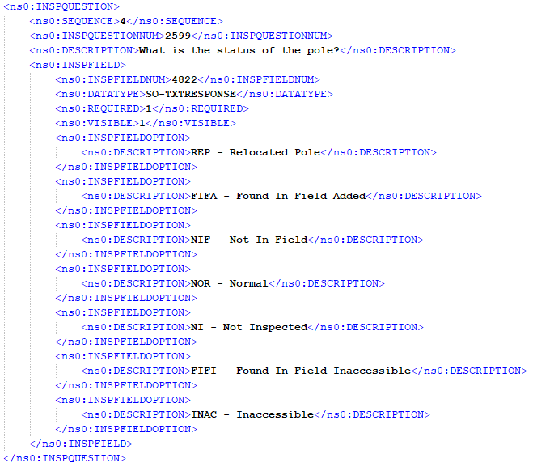

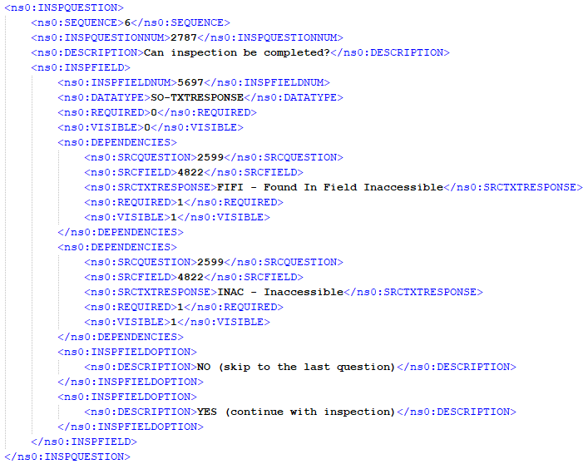

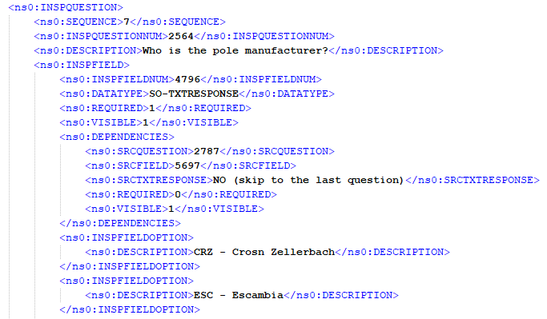

Question 4 (What is the status of the pole?) is visible and required to be answered because INSPFIELD.VISIBLE = 1 and INSPFIELD.REQUIRED = 1 and there is no DEPENDENCIES section.

Question 6 (Can inspection be completed?) is not visible and not required (INSPFIELD.VISIBLE = 0 and INSPFIELD.REQUIRED = 0) unless question 4 (INSPQUESTIONNUM 2599) is answered either “FIFI - Found In Field Inaccessible” or “INAC – Inaccessible”, in which case question 6 becomes both visible and required (DEPENDENCIES.VISIBLE = 1 and DEPENDENCIES.REQUIRED = 1).

Question 7 (Who is the pole manufacturer?) is both visible and required (INSPFIELD.VISIBLE = 1 and INSPFIELD.REQUIRED = 1) unless question 6 (INSPQUESTIONNUM 2787) is answered “NO (skip to the last question)”, in which case question 7 remains visible, but becomes no longer required (DEPENDENCIES.VISIBLE = 1 and DEPENDENCIES.REQUIRED = 0).

### DEPENDENCIES Example 2

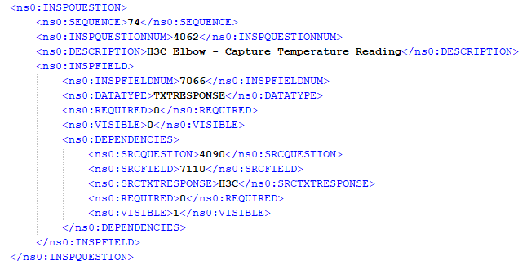

In this example, question 74 does not become required based on question 47 (INSPQUESTIONNUM 4090) because both the INSPFIELD.REQUIRED = 0 and DEPENDENCIES.REQUIRED = 0, but it does become visible (INSPFIELD.VISIBLE = 0 and DEPENDENCIES.VISIBLE = 1) if question 47 is answered “H3C”.

# Inspection Response Guidance

1. A lot of the data that is passed in via the inspection request needs to be passed back in the response to correctly link the response data back to the request in Maximo. Please do not hard code INSPQUESTIONNUM, INSPFIELNUM, SRCQUESTION, SRCFIELD, REFERENCEOBJECTID, RESULTNUM, or any other ID values in your program. These are unique IDs that will change between environments (DV/UA/PR) and if/when the form is revised. Your program needs to be dynamic enough to consume these values from the input file and pass them back in the response file.
2. Please provide a response for all questions deemed required via the logic outline above. Please only send responses for answered questions.
3. The namespace specified in the schema must be included in the response XML (http://schemas.southerncompany.com/pdmaximo/sendvendorinspection/external).



1. XML reserved characters must be escaped in your response file. For example, you must return “Sound &amp; Bore” instead of “Sound & Bore”. Below is a listing of characters that must be escaped when found within XML tags.



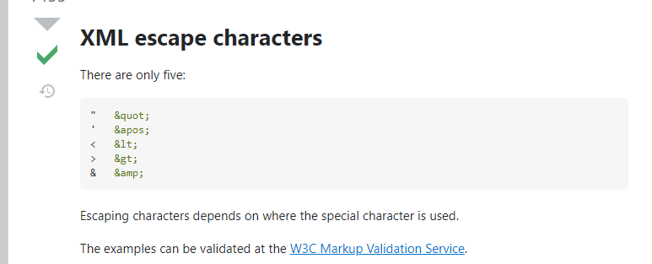

1. In order for the response file to be properly validated by our GIS program, we need the SC_COMPID and MAP_NBR (only send for poles) values passed back in the ATTRIBUTES section of the response file just as they are passed in the request (the other attributes can be omitted).

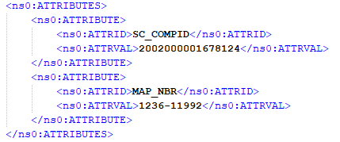

1. The GIS validation program also requires the Invoice data to be broken out as defined in the schema.

# Found In Field (FIF)

*Effective 12/11/2024*

Assets that are discovered as part of an inspection but where not in the list of assets to be inspected should be transmitted in a separate xml file. Multiple assets that were found on the same inspection can be included in the same file.

The format of this file will match the *VendorAssetInspectionResponse.xsd* provided in this document, with the following considerations.

* Tags that need to be included, but we expect them to be empty because these assets are not in our system:
  + <REFERENCEOBJECTID></REFERENCEOBJECTID>
  + <ASSETNUM></ASSETNUM>
  + <LOCATION></LOCATION>
* Coordinates need to be sent in the <ATTRIBUTES> section

* The *<RESULTNUM></RESULTNUM>* tags should contain a key value that unique to the vendor’s inspection system. With this, if there are data issues and values need to be resent we are able to replace existing inspection results with updated versions. See the *Troubleshooting* section below.

# Troubleshooting

## Data Issues

Inspections will be marked *Invalid* on the Southern-side if they meet the following criteria:

* Questions with a list of valid responses are answered with an invalid answer.
* An answer was not provided for questions that are marked as required.